

GOVERNMENT OF INDIA

**MINISTRY OF SKILL DEVELOPMENT & ENTREPRENEURSHIP**

DIRECTORATE GENERAL OF TRAINING

**NATIONAL SKILL TRAINING INSTITUTE**

Address: CP-16, CP Block, Sector V, Salt Lake City,

Kolkata-700091, West Bengal.

**CERTIFICATE**

This is to certify that following trainees have completed their project titled

**“NSTI Smart Cloud Campus”**

**For IBM Program – IT, Networking and Cloud (Technical Diploma)**

|  |  |
| --- | --- |
| **ROLL NO** | **NAME** |
| ADIT19AU03269 | RUPAMA MAJEE |

|  |  |  |
| --- | --- | --- |
| Miss. Arpita Roy | Mr.K.L.Kuli Mr.G.C.Ramamurty | Mr. Sorbojit Neyogi |
| IBM Faculty | TO / ADIT Head of office/principal | Section In-charge |

**ACKNOWLEDGEMENT**

We would like to express my sincere gratitude to several individuals and organizations for supporting me throughout my diploma study. First, I wish to express my sincere gratitude to my trainer, Miss Arpita Roy for his enthusiasm, patience, insightful comments, helpful information, practical advice and unceasing ideas that have helped me tremendously at all times in my study and writing of this project report. His immense knowledge, profound experience and professional expertise in computer science has enabled me to complete this project successfully.

I also wish to express my sincere thanks to the National Skill Training Institute(W) Saltlake,Kolkata for accepting me into the diploma program. In addition, I am deeply indebted to the Ministry of Skill Development & Entrepreneurship and IBM for granting me the diploma course. This technical and financial support has enabled me to complete my diploma course studies successfully. Also, I am grateful the Miss. Arpita Roy faculty of NSTI (W)Saltlake for supporting me for course completion in the specific subject.

I am also grateful to the following NSTI Regional Director Sir Mr. K.L. Kuli and Principal of NSTI (W) Saltlake G.C. Ramamurti & Section in charge Mr .Sarbojit Neogi for their consistent support and assistance.

|  |  |  |
| --- | --- | --- |
|  |  |  |

**ABSTRACT**

Eclipse is one of the mostly used software in professional development of programming applications and software solutions. It is open source software and provides extensive availability of free libraries.

In this thesis work, Eclipse was studied for Java applications development. To enhance the study and to get hands on experience over Eclipse IDE, an application was developed using Java programming language. The proposed application is a desktop application that can be used on all modern operating systems.

Database for event credentials was developed by MySQL database management system. The connection between application and database has been done through Java database connectivity JDBC. Some additional Java APIs were loaded to Eclipse project workspace, and a comprehensive explanation has been provided on how to use external libraries in Eclipse environment.

Keywords: Java, Eclipse, MySQL Database, Desktop Applications.

**INDEX**

|  |  |  |
| --- | --- | --- |
| **Sr. No.** | **Table of Contents** | **Page No.** |
| 1 | Chapter 1: Introduction | 5-10 |
| 2 | Chapter 2: Services and Tools Required | 11 |
| 3 | Chapter 3: Project Architecture | 12 |
| 4 | Chapter 4: Architecture Blocks Detail Working | 13-19 |
| 5 | Conclusion | 23 |
| 6 | References | 24 |
| 7 | Code | 25-50 |

**CHAPTER 1**

**INTRODUCTION**

In this activity you will see how to use Eclipse to create and test a very simple web service. Before I look at the service itself, however, I shall provide some background information about the different approaches that can be used to develop a web services.

This thesis work reflects a strong experience of Java programming language, and knowledge of connecting the applications with database. A step by step demonstration of how to do Java project in Eclipse, has been presented. There are certain questions as following that have been answered:

* How to build an application of Java SE, using Eclipse IDE?
* How to trace bugs in an application, when using Eclipse and using built in functions to fix those bugs.
* How to connect a Java application with database in Eclipse.
* The development procedure for the application required the following steps:
* Layout of the user Interface
* Coding for the application
* Creation of database for the application
* Connecting the database with application
* Deploying the application in the Tomcat Server

* 1. **Overview**

**JSP Projects** are quite popular for academic **projects** which can be used to build online portals from scratch. These **project** can be run on servers like Apache Tomcat, WebSphere or Web logic etc. You can use Eclipse, Net beans or any other J2EE supporting IDE for running these **projects** on your local machine.

**1.2 Feature**

* **JSP** technology is used to create web application just like Servlet technology. It can be thought of as an extension to Servlet because it provides more functionality than servlet such as expression language, JSTL, etc.
* A JSP page consists of HTML tags and JSP tags. The JSP pages are easier to maintain than Servlet because we can separate designing and development. It provides some additional features such as Expression Language, Custom Tags, etc.

**1.3 Advantages**

* The advantage of JSP is that the programming language used is JAVA, which is a dynamic language and easily portable to other operating systems.
* It is very much convenient to modify the regular HTML. We can write the servlet code into the JSP.
* It is only intended for simple inclusions which can use form data and make connections.
* JSP can also include the database connections into it. It can contain all type of java objects.
* It is very easy to maintain.
* Performance and scalability of JSP are very good because JSP allows embedding of dynamic elements in HTML pages.
* As it is built on Java technology, hence it is platform independent and not depending on any operating systems.
* Also, it includes the feature of multithreading of java into it.
* We can also make use of exception handling of java into JSP.
* It enables to separate presentation layer with the business logic layer in the web application.
* It is easy for developers to show as well as process the information.

**1.4 Scope**

JSP provides very useful features. One of them is maintaining the user defined variable. As you all know that in JAVA, each variable has a scope. Scope decides the accessibility of an object or variable. For example, some variables are accessible within for loop, if-else block or within specific method or class or package.

Same way, in JSP some variables needs to have different scopes than others. JSP provides the capability to user to define the scope of these variables.

JSP provides 4 scopes to a variable. Developer can assign any one of them to a variable.

1.Page.   
2.Request.  
3.Session.  
4.Application Scope.

* 1. **Future Work**

1.You've been working with JSP for years now, but I noticed that areas of growth you did **not** mention were HTML, CSS and JavaScript. How are your skills there?

2.In my opinion, creating UI on the server in order to send it to the client is already a passé technology, supplanted by JavaScript SPAs.

3.JSP and servlets will be around for a long time -- just take a look at this forum to see how may people and companies are still writing JSP as if it were 2001 -- but it's no longer the leading edge of technology in my opinion.

**CHAPTER 2**

**SERVICES AND TOOLS REQUIRED**

**2.1 Services Used**

2.1.1 Apache Tomcat Server.

**2.2 Tools and Softwares used**

2.2.1 JSP

2.2.2 HTML

2.2.3 MYSQL

**CHAPTER 3**

**PROJECT ARCHITECTURE**

**3.1 Architecture**

**USER FRONTEND BACKEND**

|  |  |  |
| --- | --- | --- |
| **User Internet** | Web design**HTML 5** | Search: jsp java Logo Vectors Free Download **JSP**  **C:\Users\Dell\Desktop\mysql.png**  **Database** |

**CHAPTER 4**

**ARCHITECTURE BLOCKS DETAIL WORKING**

* 1. **Blocks**
  + In this chapter, the theoretical background for Java, MySQL and Eclipse software is presented.
* **Introduction to Java:-**
* Java is a computing platform and high level programming language, which was developed originally by James Gosling at Sun Microsystems. A team at Sun Microsystems named “green team” started working on Java language project in 1991, which was finally released in 1995. Java has its syntax similar to and derived from C, C++ languages. Unless other languages, in which one has to either compile or interpret the code before use it, in Java we have to compile and interpret code to run it. A Java program can run on the following machines provided that they have Java virtual machine (JVM) installed. –
* Windows OS
* Linux
* Solaris
* MacOS
* **Features of Java:-**
* Object Oriented
* In Java, everything is an Object. Java can be easily extended since it is based on the Object model.
* Platform Independent
* Unlike many other programming languages including C and C++, when Java is compiled, it is not compiled into platform specific machine, rather into platform-independent byte code. This byte code is distributed over the web and interpreted by the Virtual Machine (JVM) on whichever platform it is being run on.
* Simple
* Java is designed to be easy to learn. If you understand the basic concept of OOP Java, it would be easy to master.
* Secure
* With Java's secure feature it enables to develop virus-free, tamper-free systems. Authentication techniques are based on public-key encryption.
* Architecture-neutral
* Java compiler generates an architecture-neutral object file format, which makes the compiled code executable on many processors, with the presence of Java runtime system.
* Portable
* Being architecture-neutral and having no implementation dependent aspects of the specification makes Java portable. The compiler in Java is written in ANSI C with a clean portability boundary, which is a POSIX subset.
* Robust
* Java makes an effort to eliminate error-prone situations by emphasizing mainly on compile time error checking and runtime checking.
* Multithreaded
* With Java's multithreaded feature it is possible to write programs that can perform many tasks simultaneously. This design feature allows the developers to construct interactive applications that can run smoothly.
* Interpreted
* Java byte code is translated on the fly to native machine instructions and is not stored anywhere. The development process is more rapid and analytical since the linking is an incremental and light-weight process.
* High Performance
* With the use of Just-In-Time compilers, Java enables high performance.
* Distributed
* Java is designed for the distributed environment of the internet.
* Dynamic
* 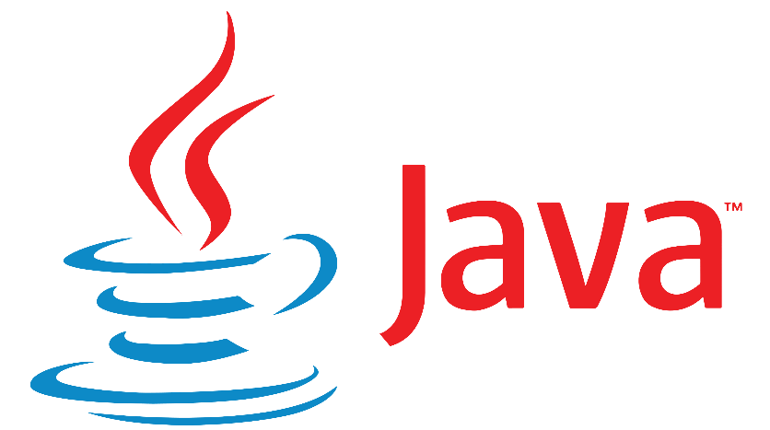Java is considered to be more dynamic than C or C++ since it is designed to adapt to an evolving environment. Java programs can carry an extensive amount of run-time information that can be used to verify and resolve accesses to objects at run-time.

# **What is HTML**

HTML is an acronym which stands for **Hyper Text Markup Language** which is used for creating web pages and web applications. Let's see what is meant by Hypertext Markup Language, and Web page.

**Hyper Text:** HyperText simply means "Text within Text." A text has a link within it, is a hypertext. Whenever you click on a link which brings you to a new webpage, you have clicked on a hypertext. HyperText is a way to link two or more web pages (HTML documents) with each other.

**Markup language:** A markup language is a computer language that is used to apply layout and formatting conventions to a text document. Markup language makes text more interactive and dynamic. It can turn text into images, tables, links, etc.

**Web Page:** A web page is a document which is commonly written in HTML and translated by a web browser. A web page can be identified by entering an URL. A Web page can be of the static or dynamic type. **With the help of HTML only, we can create static web pages**.

Hence, HTML is a markup language which is used for creating attractive web pages with the help of styling, and which looks in a nice format on a web browser. An HTML document is made of many HTML tags and each HTML tag contains different content.

## Features of HTML

1) It is a very **easy and simple language**. It can be easily understood and modified.

2) It is very easy to make an **effective presentation** with HTML because it has a lot of formatting tags.

3) It is a **markup language**, so it provides a flexible way to design web pages along with the text.

4) It facilitates programmers to add a **link** on the web pages (by html anchor tag), so it enhances the interest of browsing of the user.

5) It is **platform-independent** because it can be displayed on any platform like Windows, Linux, and Macintosh, etc.

6) It facilitates the programmer to add **Graphics, Videos, and Sound** to the web pages which makes it more attractive and interactive.

7) HTML is a case-insensitive language, which means we can use tags either in lower-case or upper-case.

* **Introduction to MySQL:-**
* MySQL is the world’s most popular and mostly used database management system. It is an open source RDBMS (relational database management system) and popular choice to use in web as well as desktop applications. The phrase SQL stands for structured query language. The most important thing in SQL is the tables, since the data is saved in the form of tables that makes it easy to access, retrieve and modify the data.
* **Features of MySQL:-**
* Relational Database Management System (RDBMS)
* MySQL is a relational database management system. This database language is based on the SQL queries to access and manage the records of the table.
* Easy to use
* MySQL is easy to use. We have to get only the basic knowledge of SQL. We can build and interact with MySQL by using only a few simple SQL statements.
* It is secure
* MySQL consists of a solid data security layer that protects sensitive data from intruders. Also, passwords are encrypted in MySQL.
* Client/ Server Architecture
* MySQL follows the working of a client/server architecture. There is a database server (MySQL) and arbitrarily many clients (application programs), which communicate with the server; that is, they can query data, save changes, etc.
* Free to download
* MySQL is free to use so that we can download it from MySQL official website without any cost.
* It is scalable
* MySQL supports multi-threading that makes it easily scalable. It can handle almost any amount of data, up to as much as 50 million rows or more. The default file size limit is about 4 GB. However, we can increase this number to a theoretical limit of 8 TB of data.
* Speed
* MySQL is considered one of the very fast database languages, backed by a large number of the benchmark test.
* High Flexibility
* MySQL supports a large number of embedded applications, which makes MySQL very flexible.
* Compatible on many operating systems
* MySQL is compatible to run on many operating systems, like Novell NetWare, Windows* Linux*, many varieties of UNIX* (such as Sun* Solaris*, AIX, and DEC* UNIX), OS/2, FreeBSD*, and others. MySQL also provides a facility that the clients can run on the same computer as the server or on another computer (communication via a local network or the Internet).
* Allows roll-back
* MySQL allows transactions to be rolled back, commit, and crash recovery.
* Memory efficiency
* Its efficiency is high because it has a very low memory leakage problem.
* High Performance
* MySQL is faster, more reliable, and cheaper because of its unique storage engine architecture. It provides very high-performance results in comparison to other databases without losing an essential functionality of the software. It has fast loading utilities because of the different cache memory.
* High Productivity
* MySQL uses Triggers, Stored procedures, and views that allow the developer to give higher productivity.
* Platform Independent
* It can download, install, and execute on most of the available operating systems.
* Partitioning
* This feature improves the performance and provides fast management of the large database.
* GUI Support
* MySQL provides a unified visual database graphical user interface tool named "MySQL Workbench" to work with database architects, developers, and Database Administrators. MySQL Workbench provides SQL development, data modelling, data migration, and comprehensive administration tools for server configuration, user administration, backup, and many more. MySQL has a fully GUI supports from MySQL Server version 5.6 and higher.
* Dual Password Support
* MySQL version 8.0 provides support for dual passwords: one is the current password, and another is a secondary password, which allows us to transition to the new password.
* **Disadvantages/Drawback of MySQL:-**
* MySQL version less than 5.0 doesn't support ROLE, COMMIT, and stored procedure.
* MySQL does not support a very large database size as efficiently.
* MySQL doesn't handle transactions very efficiently, and it is prone to data corruption.
* MySQL is accused that it doesn't have a good developing and debugging tool compared to paid databases.
* 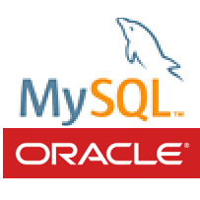MySQL doesn't support SQL check constraints
* **Introduction to Eclipse IDE:-**
* Eclipse is a multi-lingual software development environment, which consists of integrated development environment (IDE) and extra plug-in system. An IDE provides many different tools e.g. code writing, compiling, running, debugging, file management, and documentation all at one single platform.
* Eclipse is one of the IDEs which are mostly used professionally to develop applications and software solutions. An advantage of Eclipse over other professional IDEs is that Eclipse is an open source platform, and therefore, it is easy to add new libraries and resources in it. Most of it is written in Java programming language.
* There are a variety of languages, whose applications can be developed in Eclipse by means of extensible plug-in systems. Some of mostly programmed languages in Eclipse are JAVA, C, C++, COBOL, Perl, Android, Python, Ruby, Groovy and Scheme [10].
* Below is a Figure that shows typical interactive environment of Eclipse, for the development of an application.

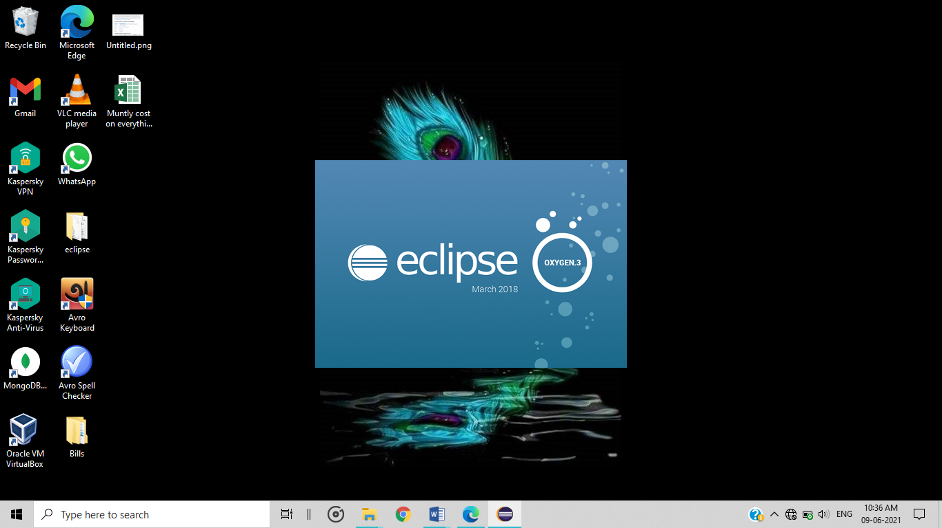

**CHAPTER 5**

**PROJECT BUDGET**

|  |  |  |  |
| --- | --- | --- | --- |
| **Sr. No** | **Cloud Services and Coding Cost** | **Single Price (Rs)** | **Total** |
|  |  | N/A |  |
|  |  |  |  |
|  |  |  |  |
|  |  |  |  |
|  |  |  |  |
|  |  |  |  |
|  |  |  |  |
|  |  |  |  |
|  |  |  |  |
|  |  |  |  |
|  |  |  |  |
|  |  |  |  |
|  |  |  |  |
| Total | | |  |

**CHAPTER 6**

**ENTERPRISE PRODUCTS APPLIED**

**6.1 Enterprise Products Used in Projects**

Not use any Enterprise Products

**CHAPTER 7**

**ENTERPRISE PRODUCTS DETAILS**

N/A

**CONCLUSION**

Application development in Eclipse environment has been explained and the experiment to develop Java desktop application has been done. The tasks which were covered in the study are as follows:

* Step wise explanation of how to develop Java applications in Eclipse IDE.
* How to connect between Java applications on MySQL Database.
* How to deploy Java applications on Tomcat server.

Eclipse IDE, being a professional-grade development platform has one bigger advantage over other IDEs, that is, it is open source, and it is therefore easy to add new free libraries in it. Experiment to load external libraries in Eclipse project was done successfully. The proposed Java application needed to add external Java archive (jar) files, to make the development easy; in the case the jar files contained packages, which have necessary classes used in the project.

**REFERENCES**

To accomplish the project of “BUILD AN APPLICATION USING JAVA ON THE ECLIPSE, CONNECT IT THE MYSQL DATABASE & DEPLOY IT TOMCAT SERVER” we take help of the following sites:

* <https://www.tutorialspoint.com/What-are-the-major-features-of-Java-programming>
* <https://www.google.com/url?sa=i&url=https%3A%2F%2Fmedium.com%2Fcorda%2Fhow-to-develop-a-blockchain-application-if-you-only-know-java-f93dcf52cb60&psig=AOvVaw0E8F1tYCpBlSunu7CHsh45&ust=1623303852674000&source=images&cd=vfe&ved=0CAIQjRxqFwoTCKi_26HsifECFQAAAAAdAAAAABAD>
* <https://www.javatpoint.com/mysql-features>
* <https://www.google.com/url?sa=i&url=https%3A%2F%2Fgithub.com%2Fmysql&psig=AOvVaw3k_jDJRHWybplY24AphFjT&ust=1623304900047000&source=images&cd=vfe&ved=0CAIQjRxqFwoTCOj7mp3wifECFQAAAAAdAAAAABAD>
* Google.com

**SCREENSHOTS**

***Create a Project in Eclipse***

* Step 1:- To launch Eclipse software, double click the “**eclipse.exe”** file in windows.

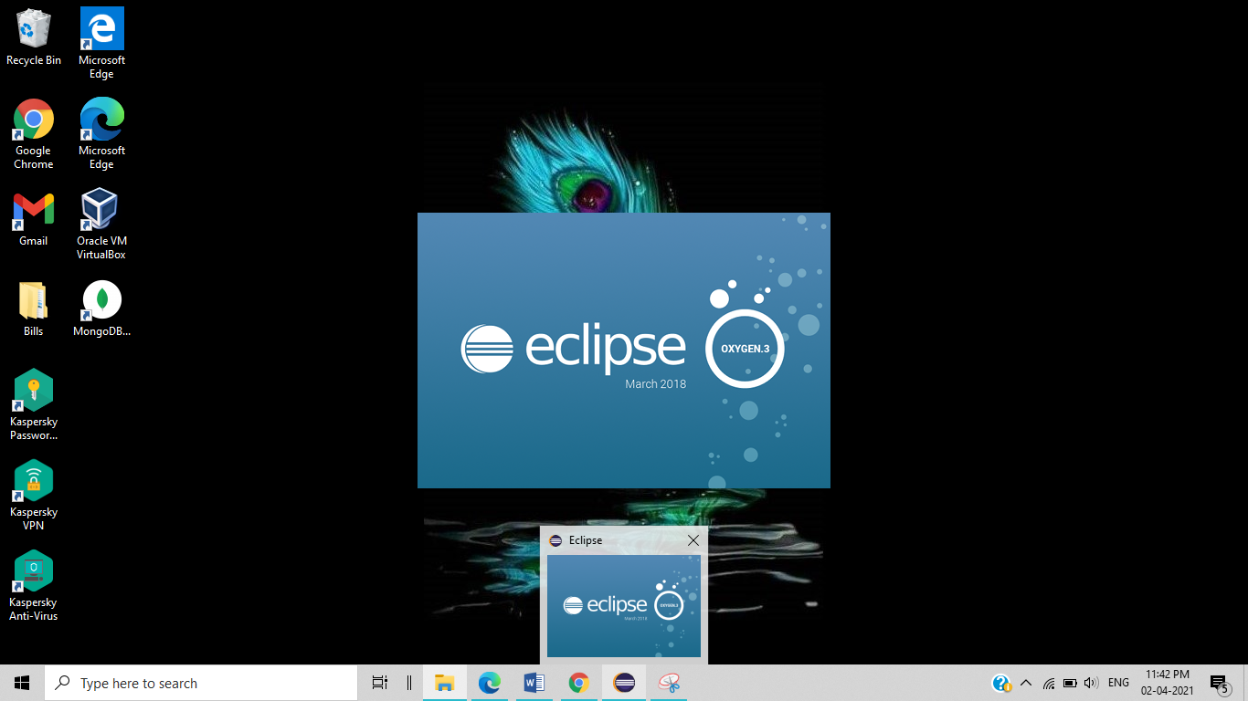

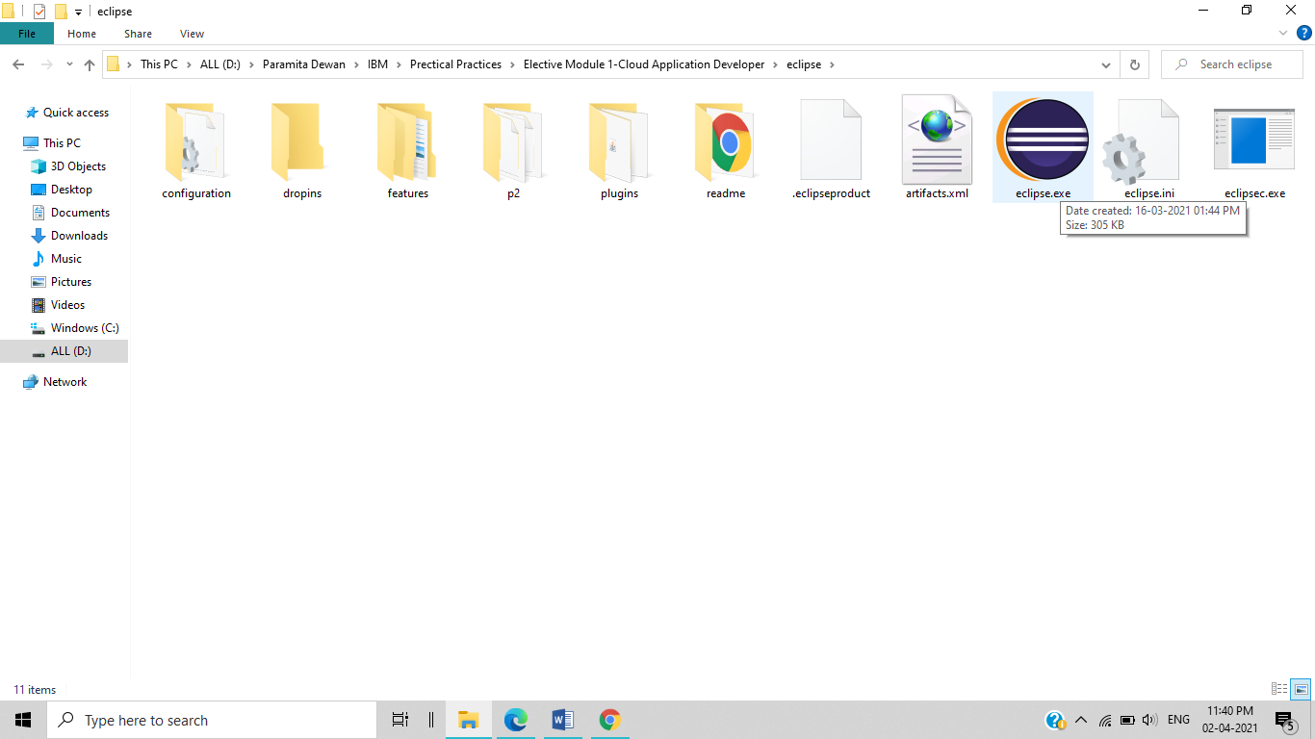

* Step 2:- After that open this window. Click this **cross**.

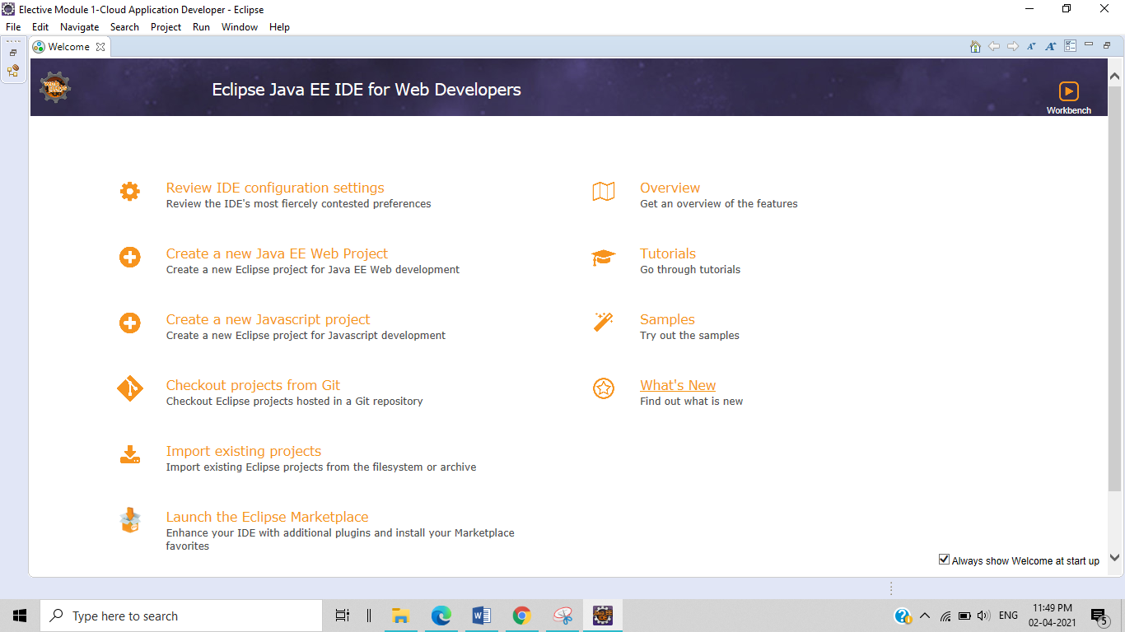

* Step 3:- After that open this window.
* 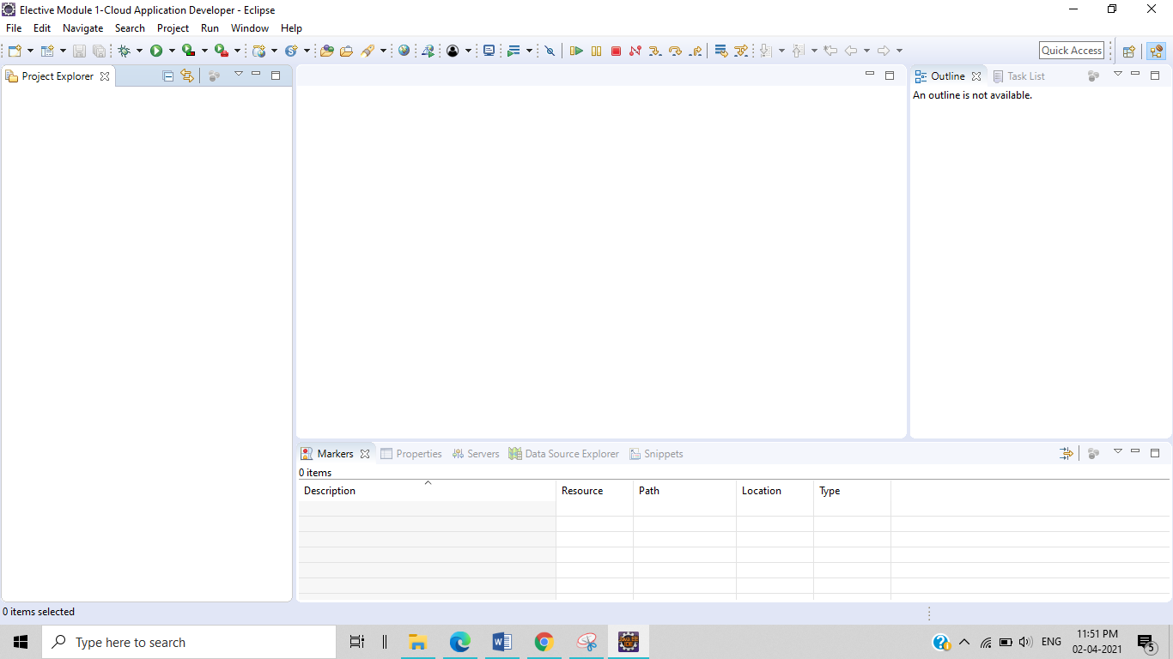
* Step 4:- After that to start a project, Click **File > New >** **Dynamic Web Project.**

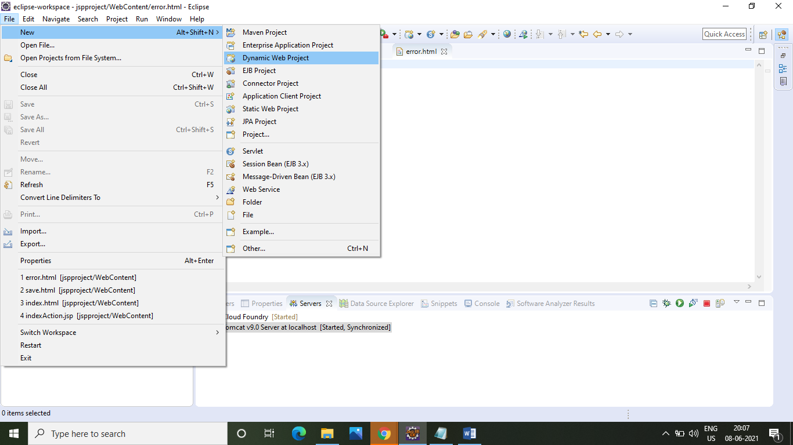

* Step 5:- After that enter the name of the project& Click **Next**.

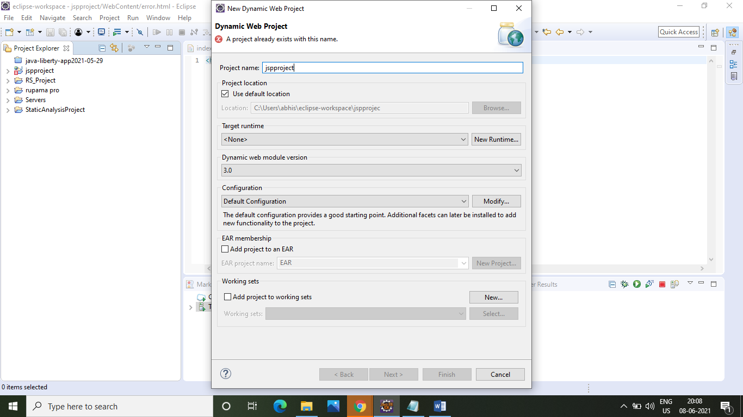

* Step 6:- After that to select **src > Next**.

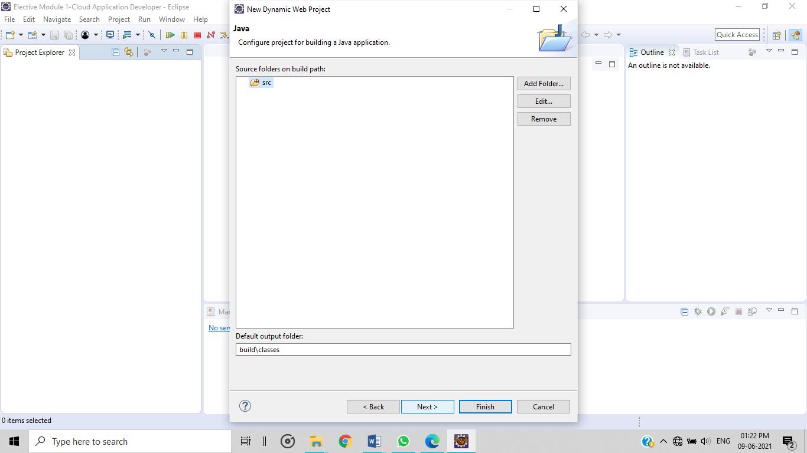

* Step 7:- After that to tick the box & Click **finish.**

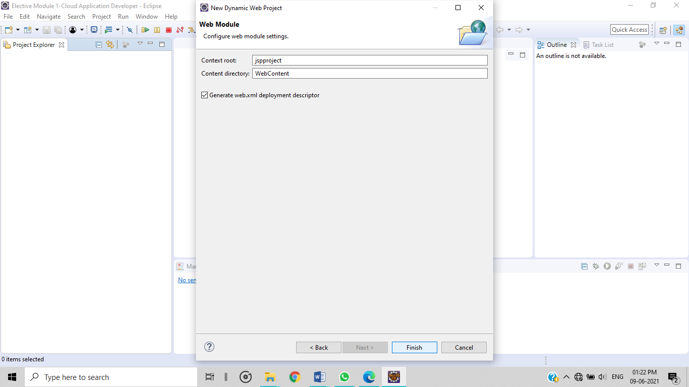

* Step 8:- After that successfully create a project file “**jspproject”.**

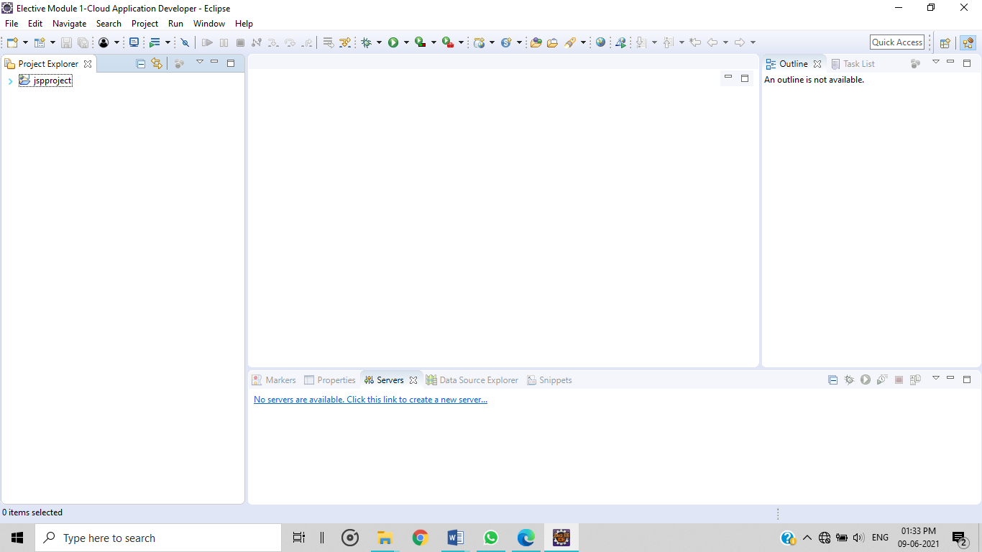

* Step 9:- After that select the project name & right click **New>Others**.

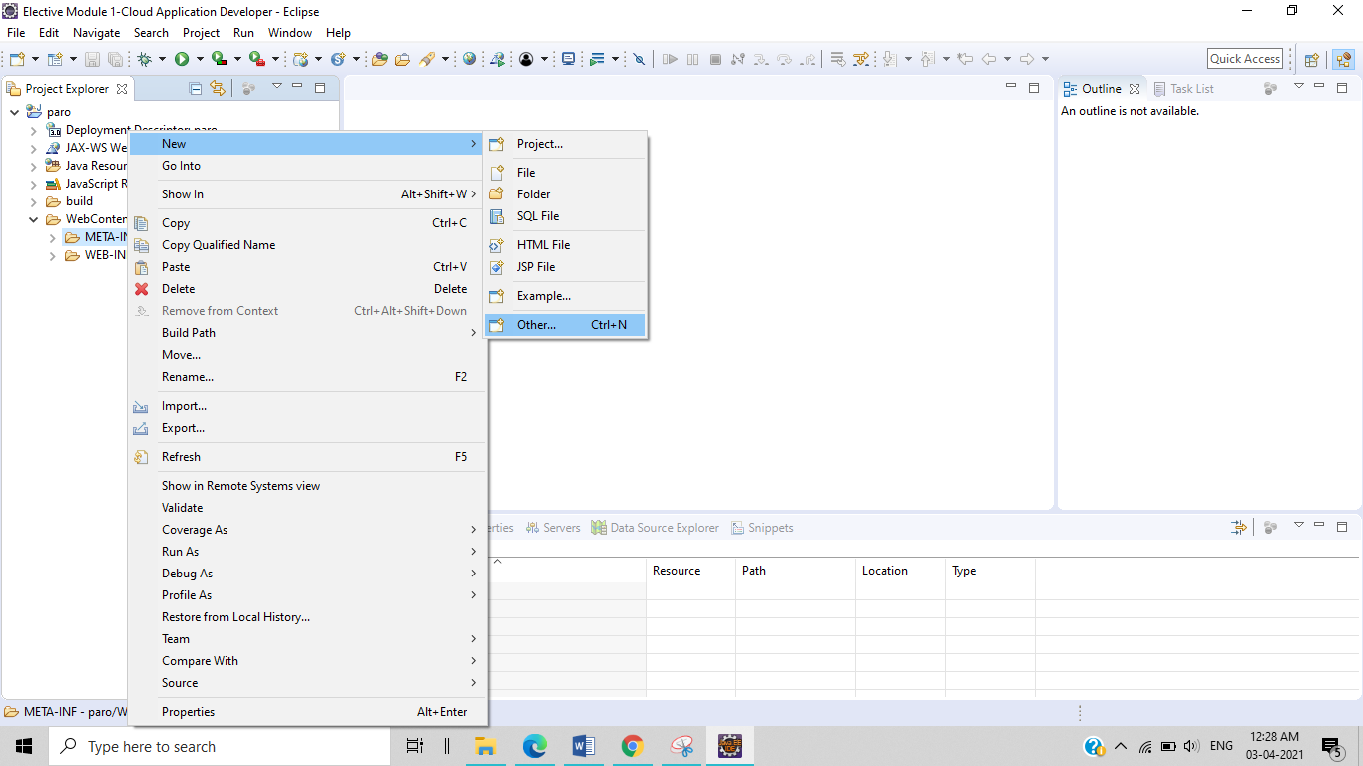

* Step 10:- After that create the project click **Web>HTML file>next**.

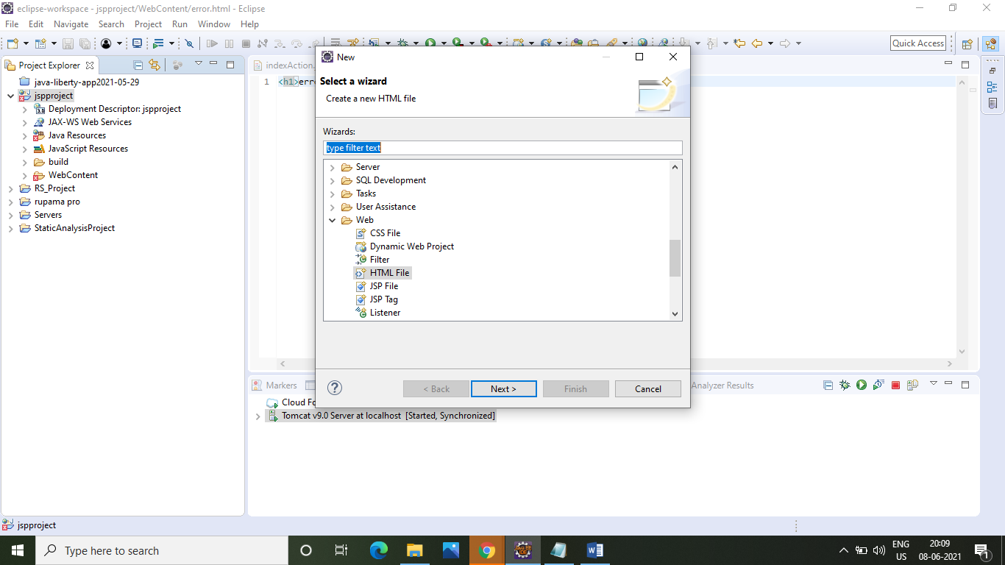

* Step 11:- After that to start a project, click **Finest**.

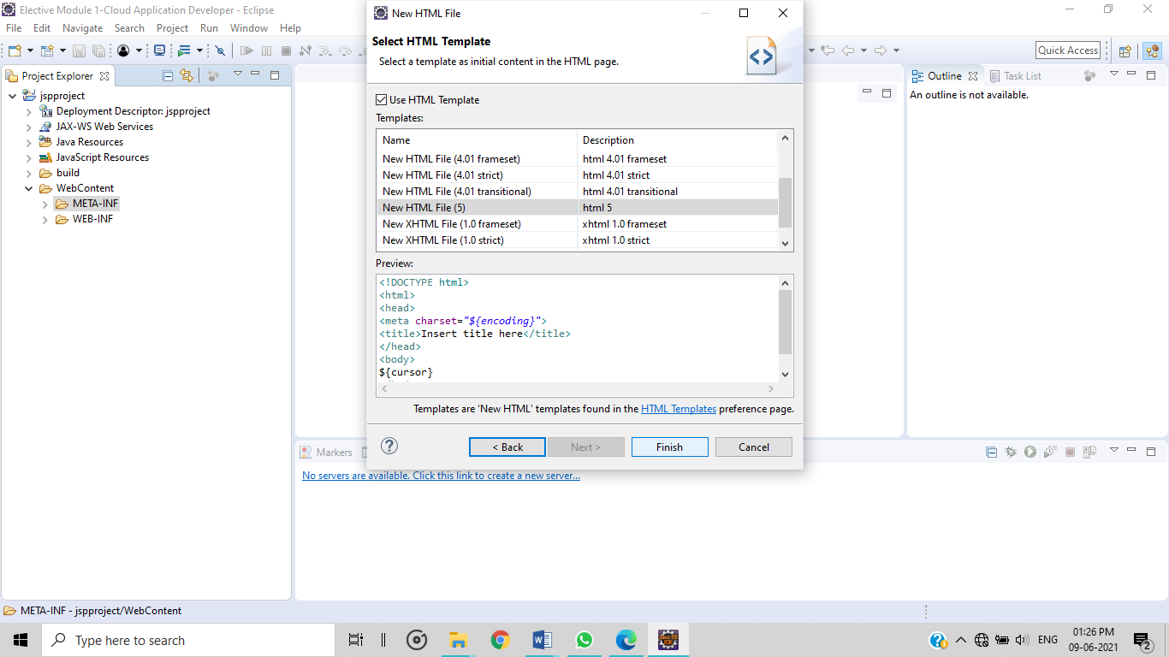

* Step 12:- After that successfully create a **HTML file** “**index.html”.** Now write this code -

<form action="indexAction.jsp" method="post">

<fieldset>

<label for="fname">Name</label>

<input type="text" name="name"> <br>

<label for="fname">Mobile no</label>

<input type="number" name="mobileNo"> <br>

<label for="fname">Email</label>

<input type="email" name="email"> <br>

<label for="fname">Password</label>

<input type="password" name="password"> <br><br>

<input type="submit" value="submit"> <br>

</fieldset>

</form>

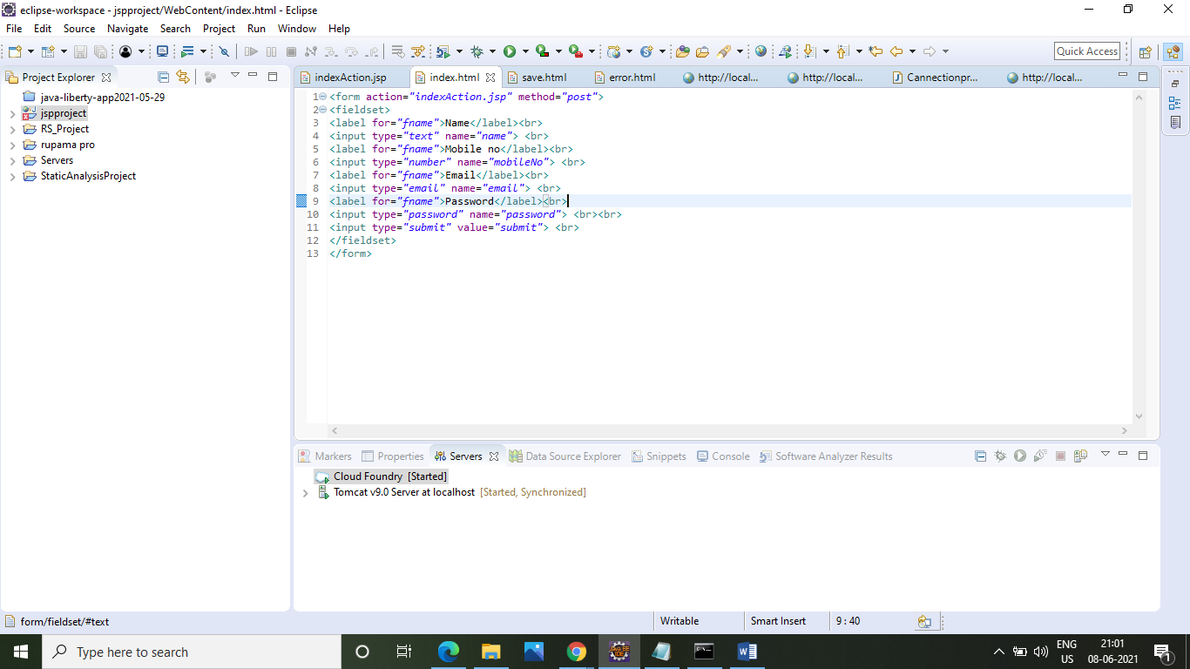

* Step 13:- After that once more create another HTML file click **Web>HTML file>next>next>finish**.



* Step 14:- After that successfully create a **HTML file** “**save.html”.** Now write this code –

<h1>successful</h1>

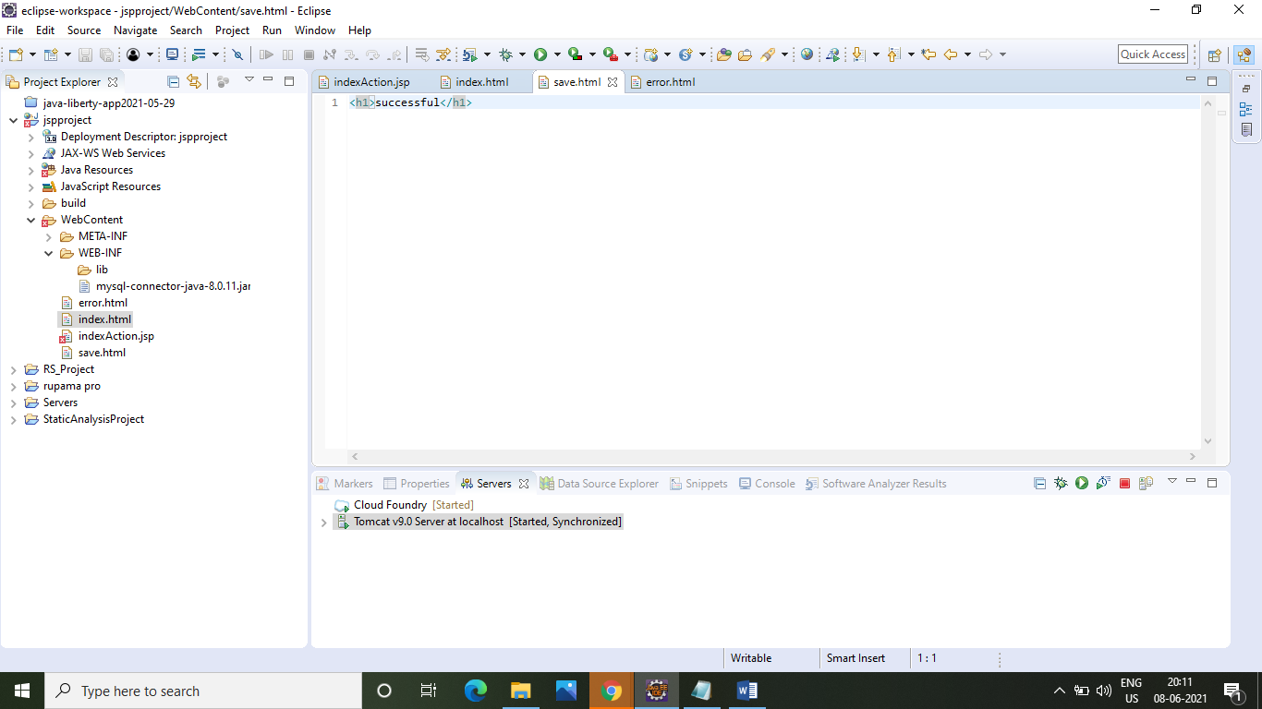

* Step 15:- After that once more create another HTML file click **Web>HTML file>next>next>finish**.



* Step 16:- After that successfully create a **HTML file** “**error.html”.** Now write this code –

<h1>error</h1>

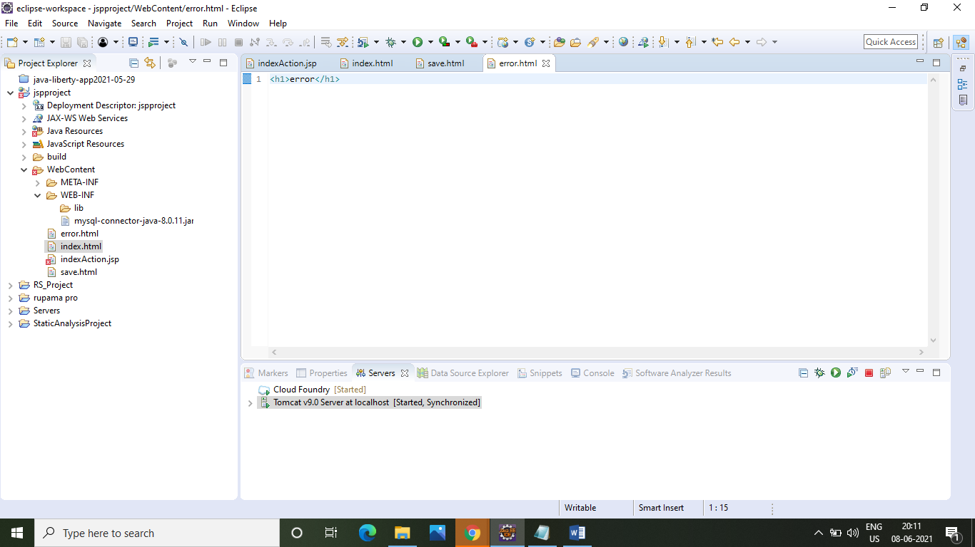

* Step 17:- After that create JSP file click **Web>JSP file>next**.

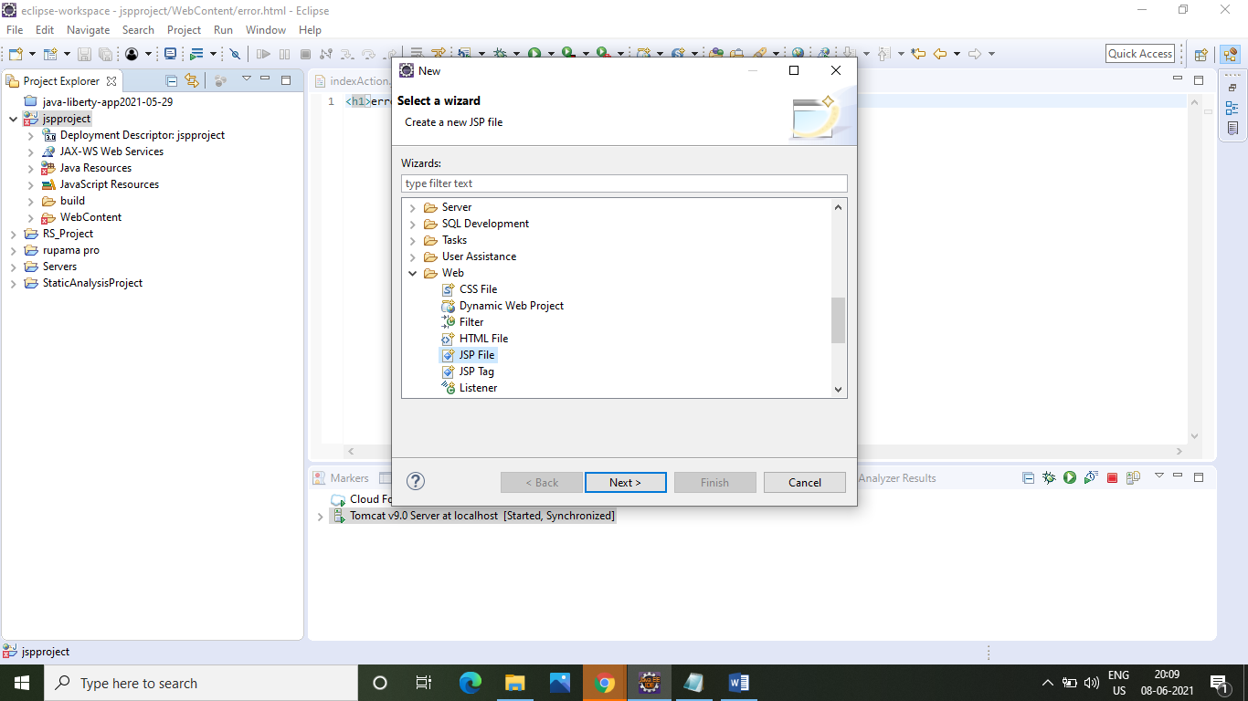

* Step 18:- After that giving the **JSP file** “**indexAction.jsp” >next**.

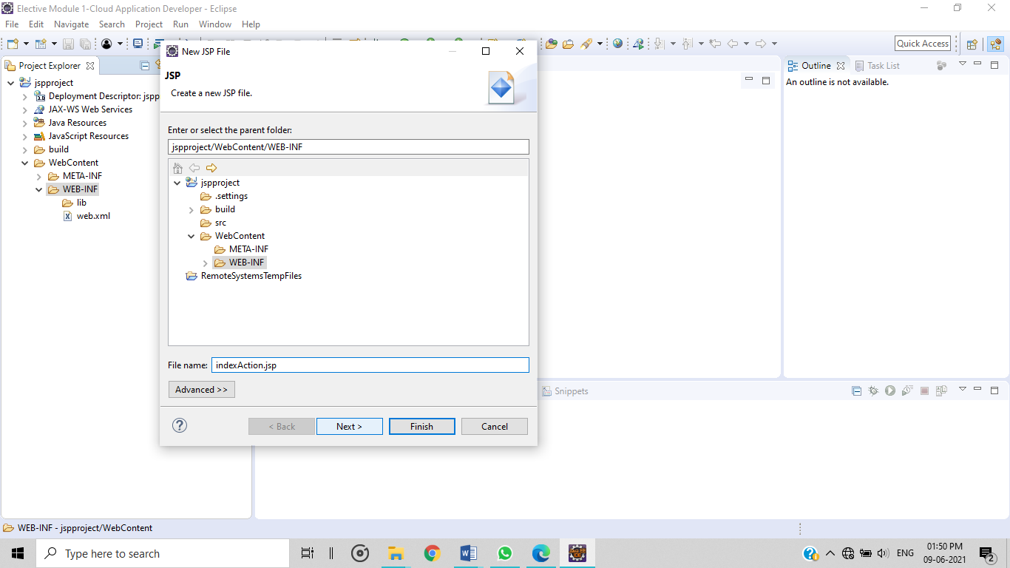

* Step 19:- After that click **Finest**.

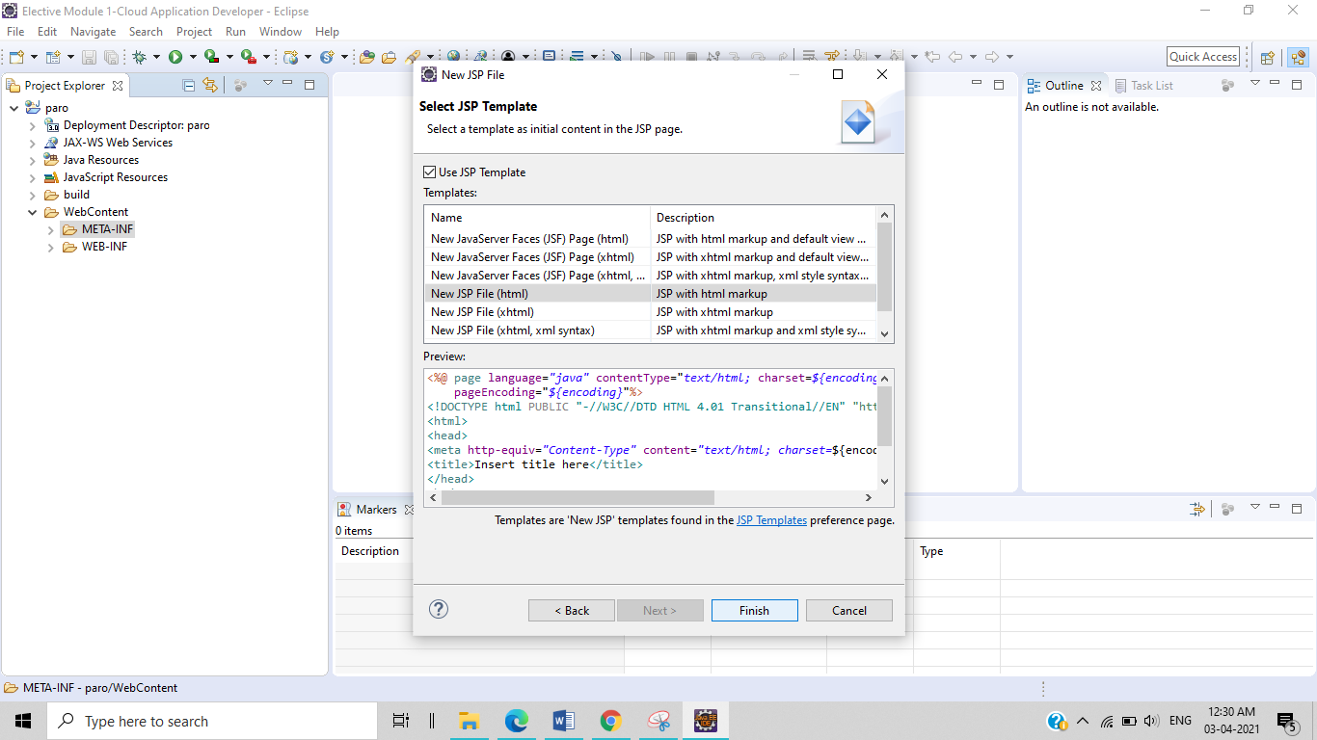

* Step 20:- After that successfully create a **JSP file** “**indexAction.jsp”.** Now write this code –

<%@page import="java.sql.*"%>

<%

String name=request.getParameter("name");

String mobileNo=request.getParameter("mobileNo");

String email=request.getParameter("email");

String password=request.getParameter("password");

try

{

Class.forName("com.mysql.jdbc.Driver");

Connection con=DriverManager.getConnection("jdbc:mysql://localhost:3306/user","root","Rupama@1996");

Statement st=con.createStatement();

st.executeUpdate("insert into user(name,mobileNo,email,password) values('"+name+"','"+mobileNo+"','"+email+"','"+password+"')");

response.sendRedirect("save.html");

}

catch(Exception e)

{

response.sendRedirect("error.html");

}

%>

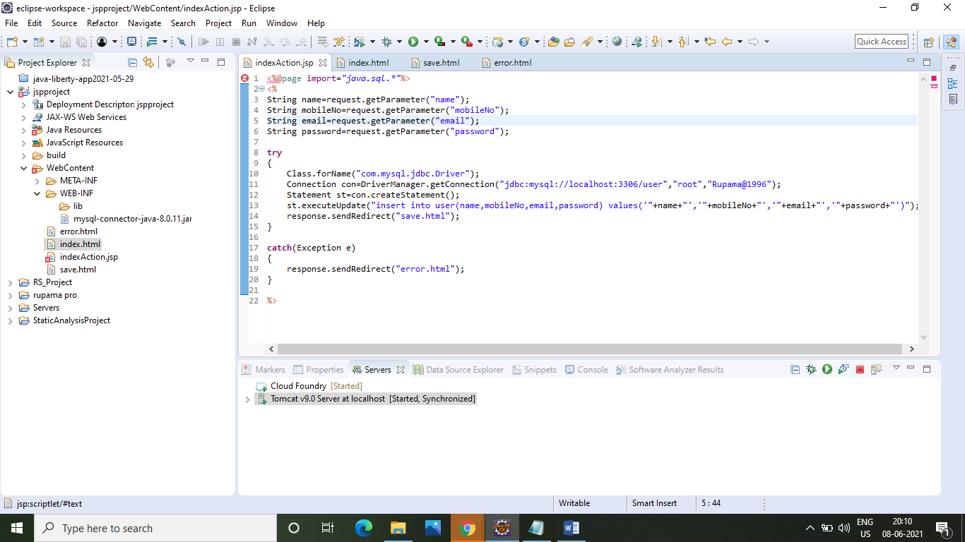

* Step 21:- After that create a connector project, Click **File > connector project** give the project name **>** **next**

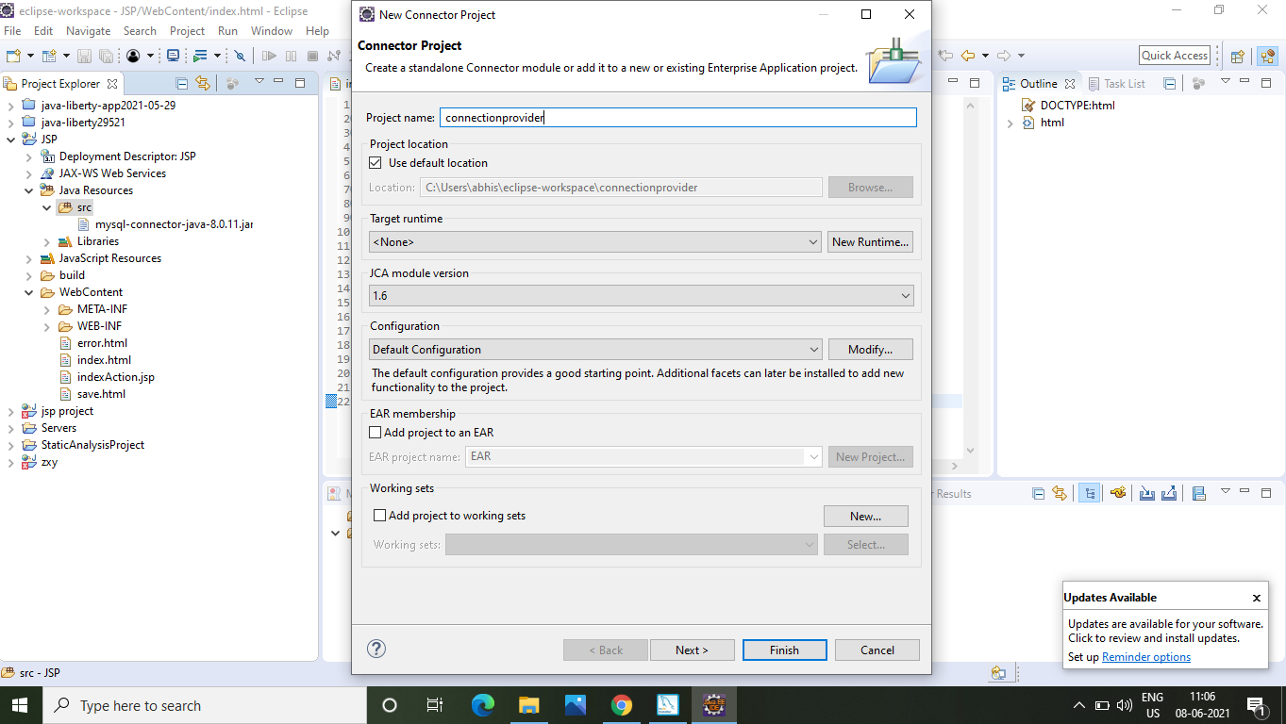

* Step 22:- After that to select the source folders, click **finish**.

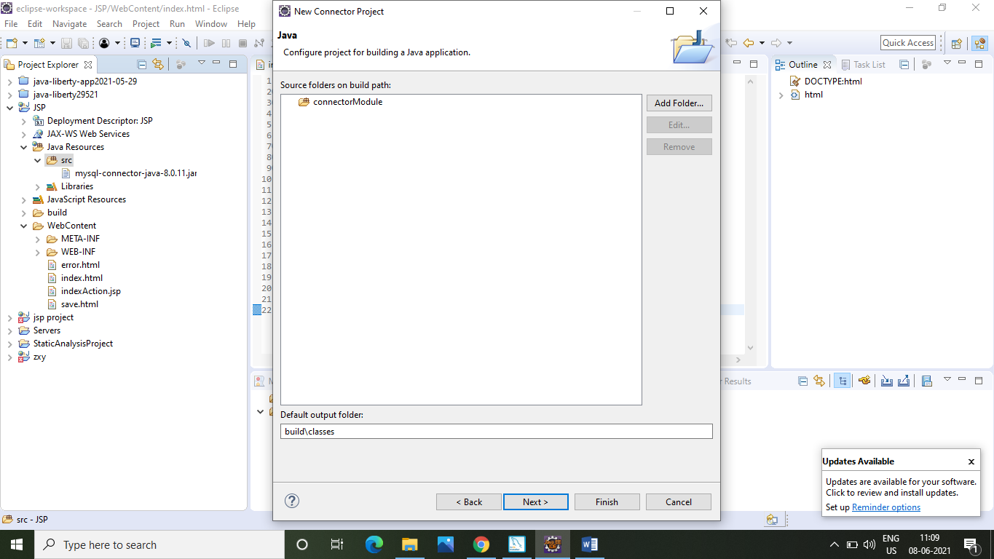

* Step 23:- After that open **File Explore > copy** the **mysql-connector-java-8.0.19 (jar file)**.

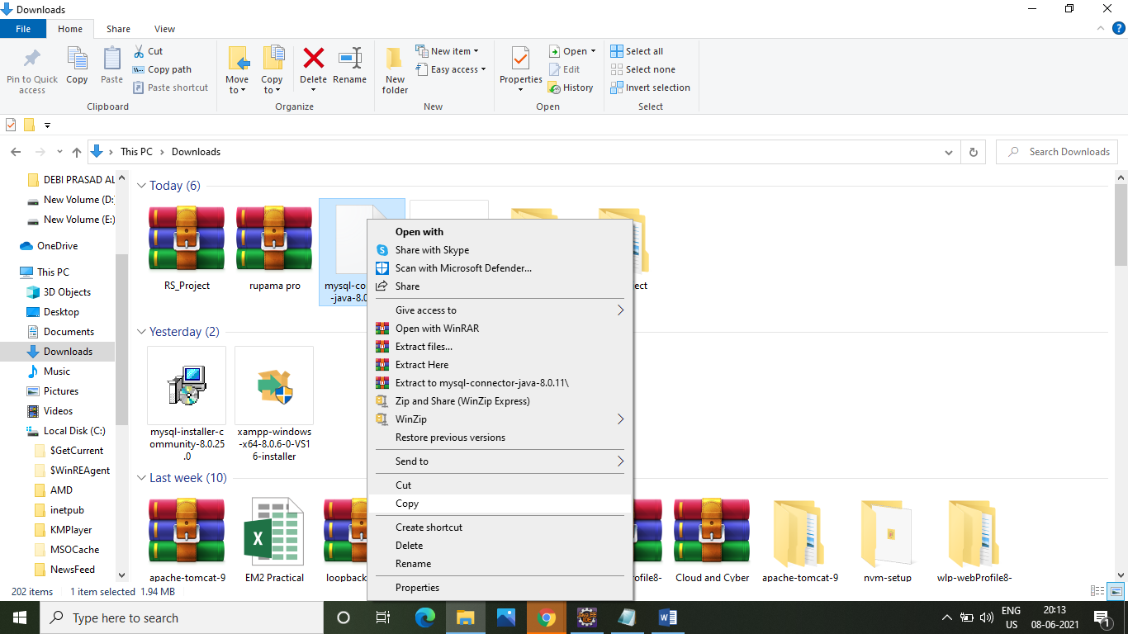

* Step 24:- After that select the location right click where **paste** this file.

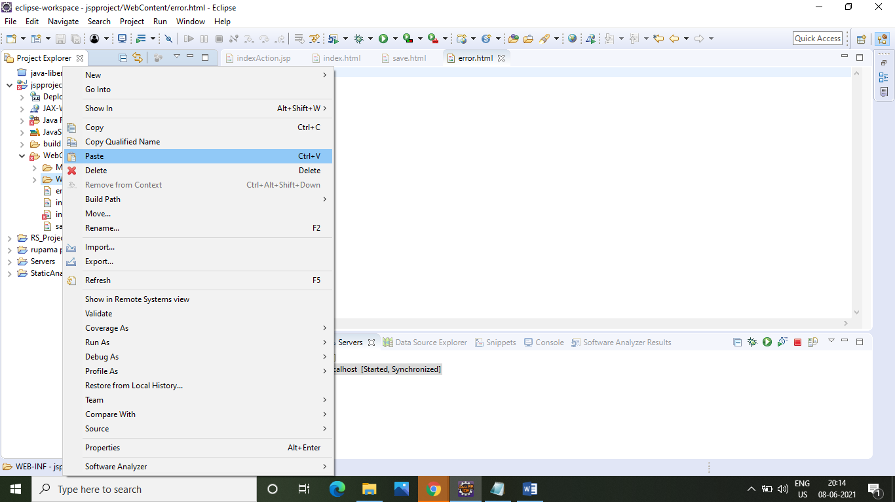

* Step 25:- After that create a serve, go to the **Server>**right Click the **link>New >** **Server**.

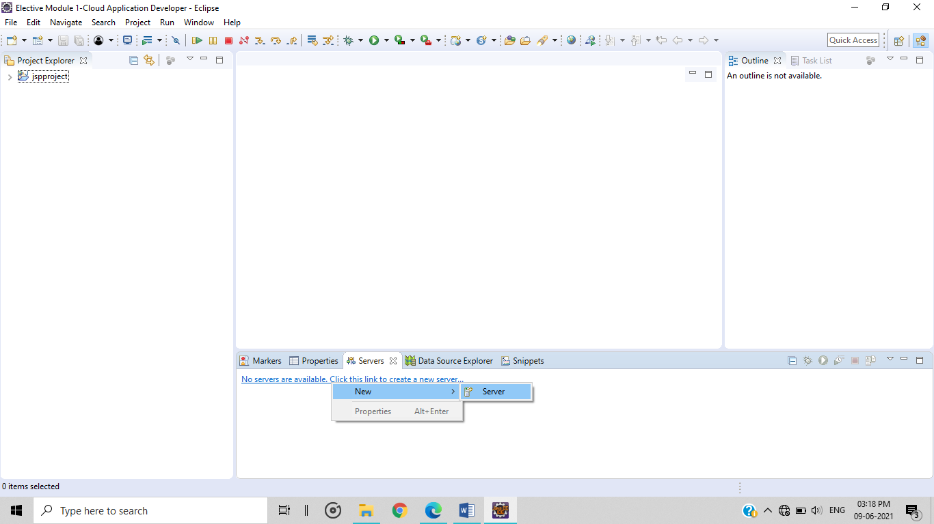

* Step 26:- After that to select **Apache > Tomcat v9.0 Server >** **Next**

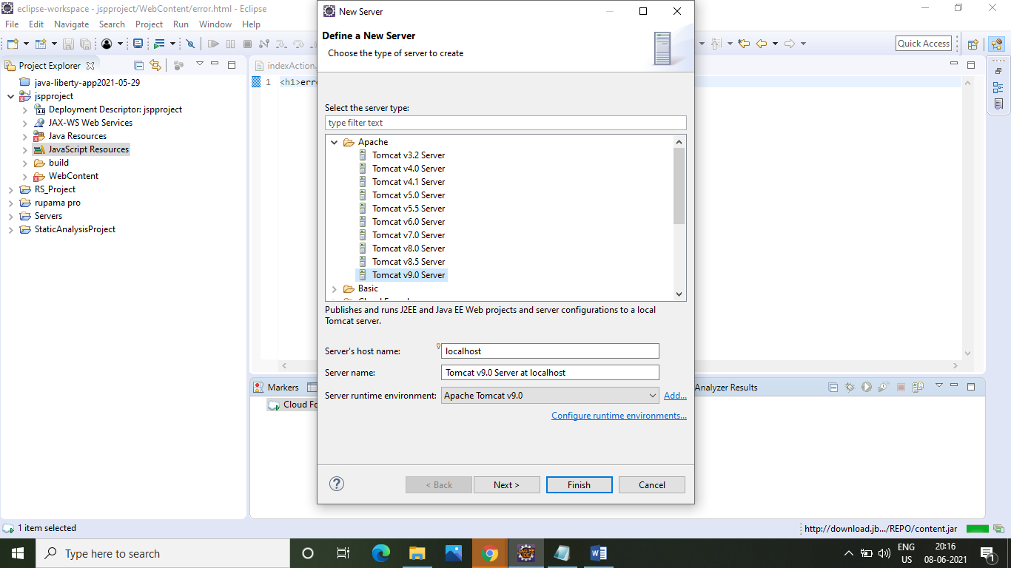

* Step 27:- After that available project **add** onconfigured portion & click **Finish**.

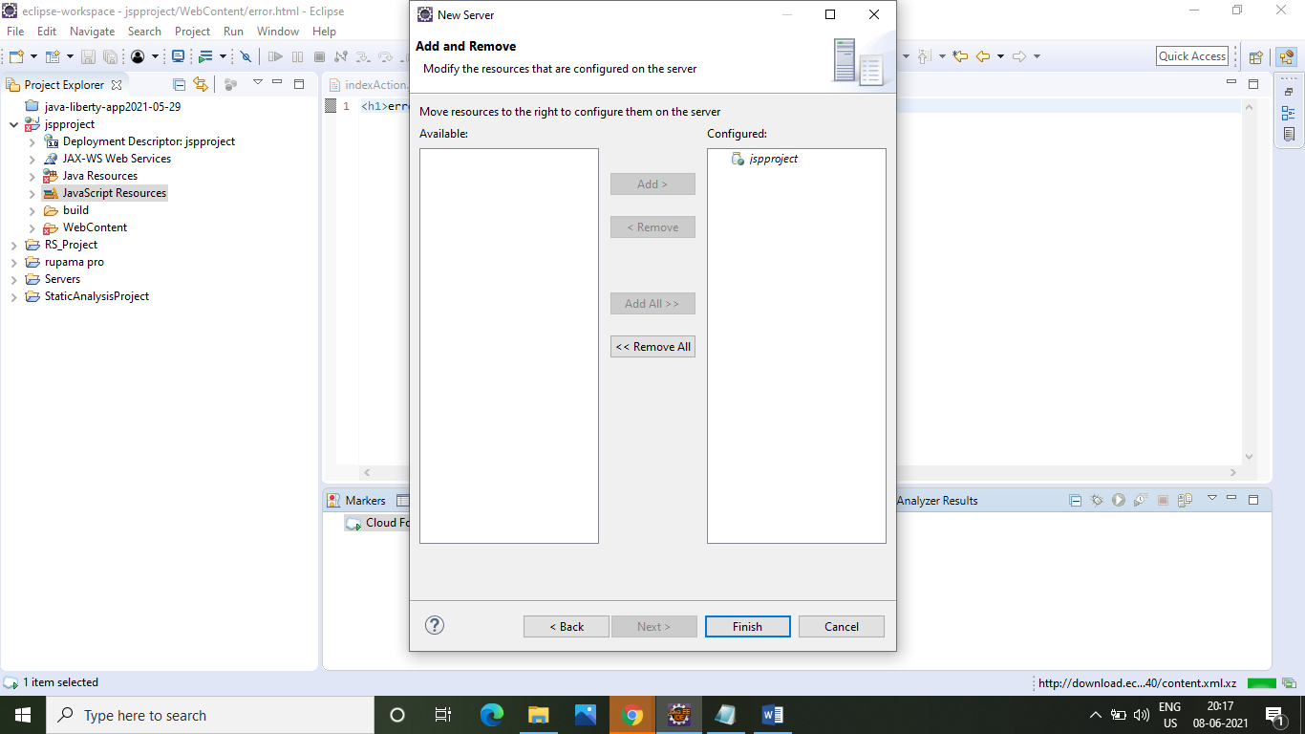

* Step 28:- After that successful create a **Tomcat Server**, Click project file **> Run As >** **1 Run on Server**.

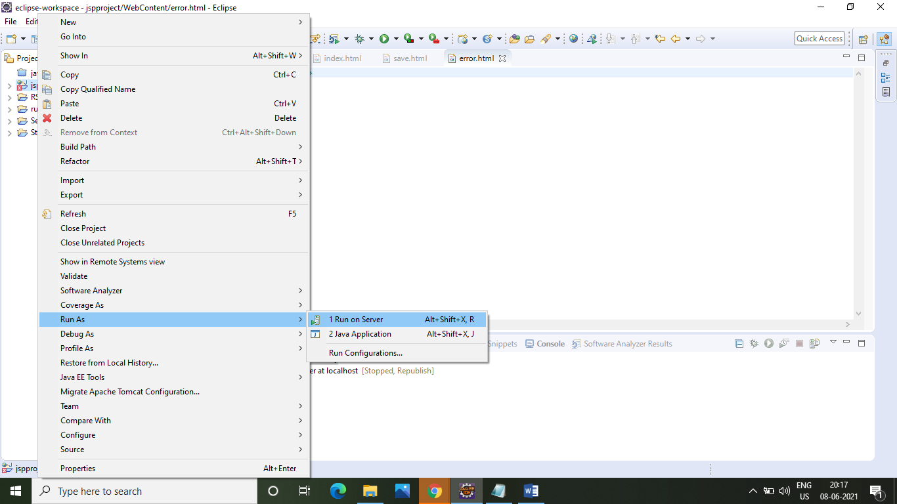

* Step 29:- After that select Tomcat **> Finish**.

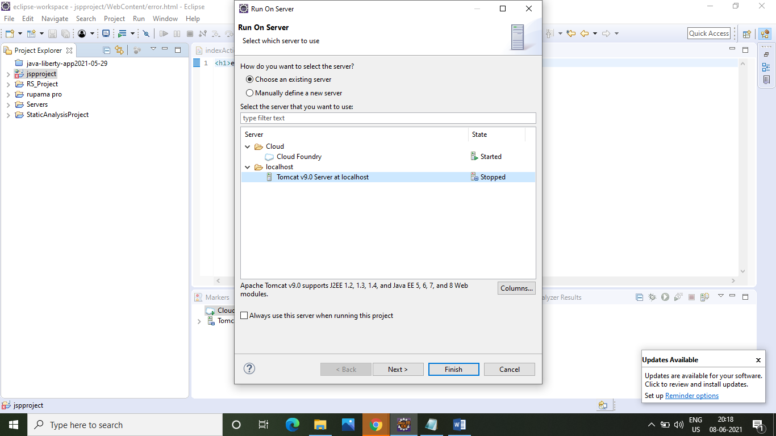

* Step 30:- After that to successfully deploy the project on localhost to using Tomcat server.

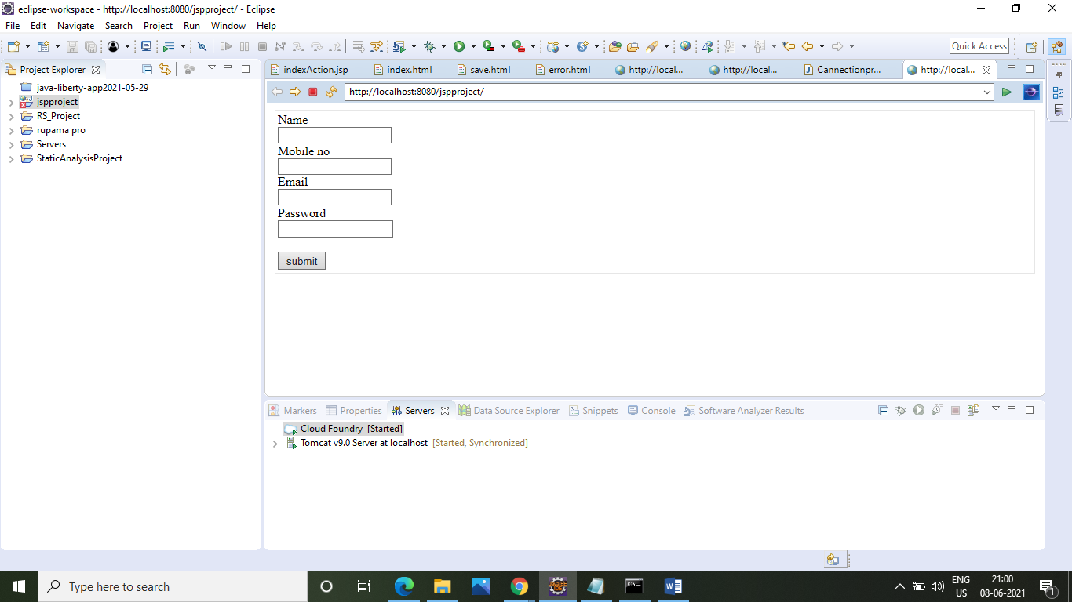

* Step 31:- After that now open **CMD >** & write **MySQL syntax.** To create a database & table & connect it to our application. First write this command & password to enter the MySQL database.

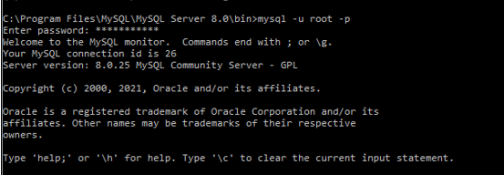

* Step 32:- After that “**create database”** command & give database name “**rupamadb”**.



* Step 33:- After that write “**use**” command to go under the new create database.

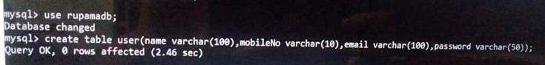

* Step 34:- After that create table to use “**create table”** command & give table name “**user”**.



* Step 35:- After that show the table format to use “**desc user”** command.

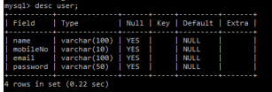

* Step 36:- After that go to the **eclipse** & enter the **correct data** & enter the **submit button** to store this data on the database.

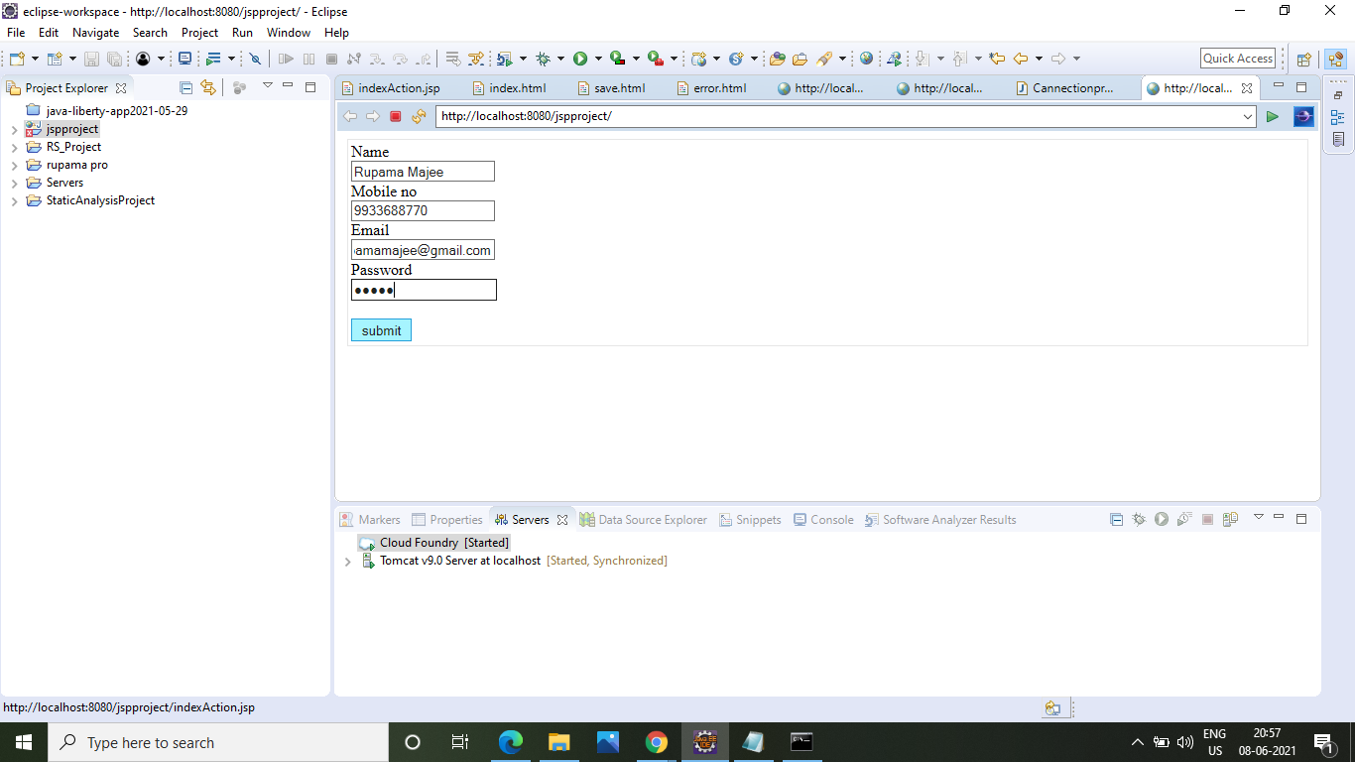

* Step 37:- After that when data successfully submitted then show the **successful** page.

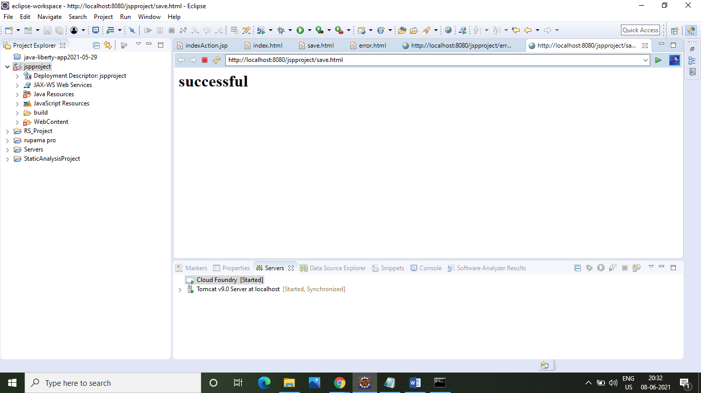

* Step 38:- After that enter the **incorrect data** & enter the **submit button** to store this data on the database.

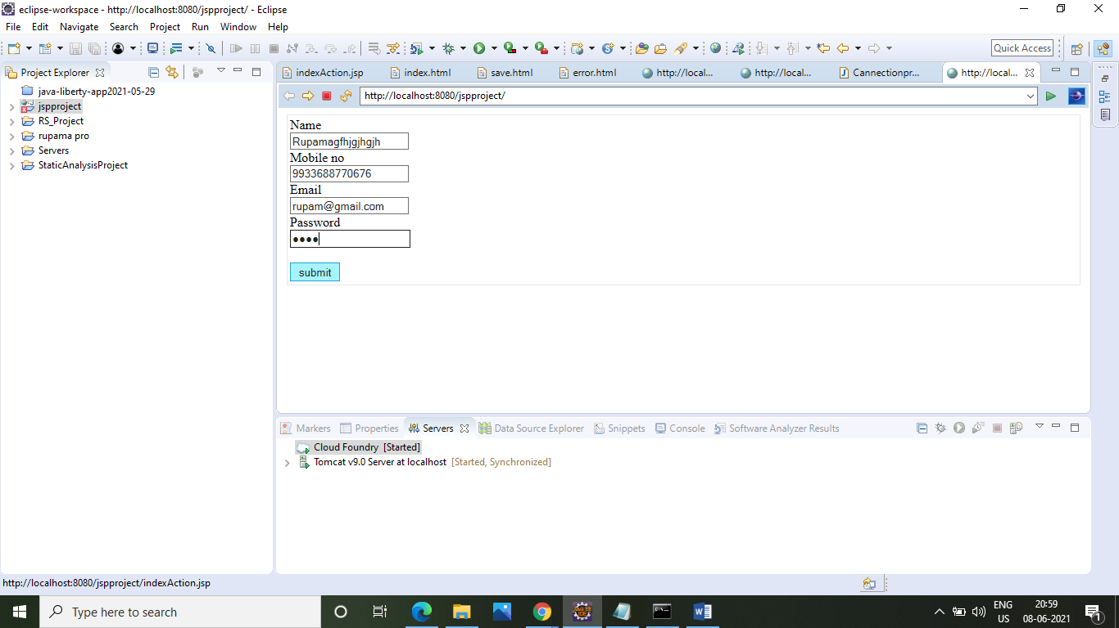

* Step 39:- After that when data not successfully submitted then show the **error** page.

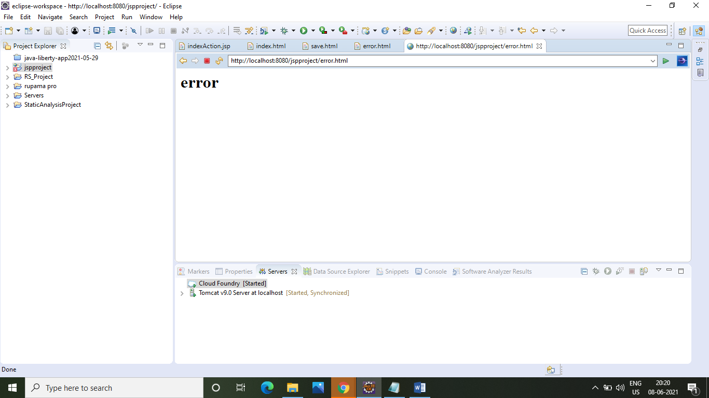

* Step 40:- Data store in the table format to use “**from user”** command.

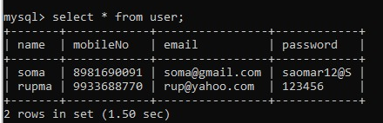

THANK YOU